Week 2 – Maven Assignment

• Write shell scripts / batch files to list out all the mvn goals available

**Mvn help:describe –Dplugin=eclipse**

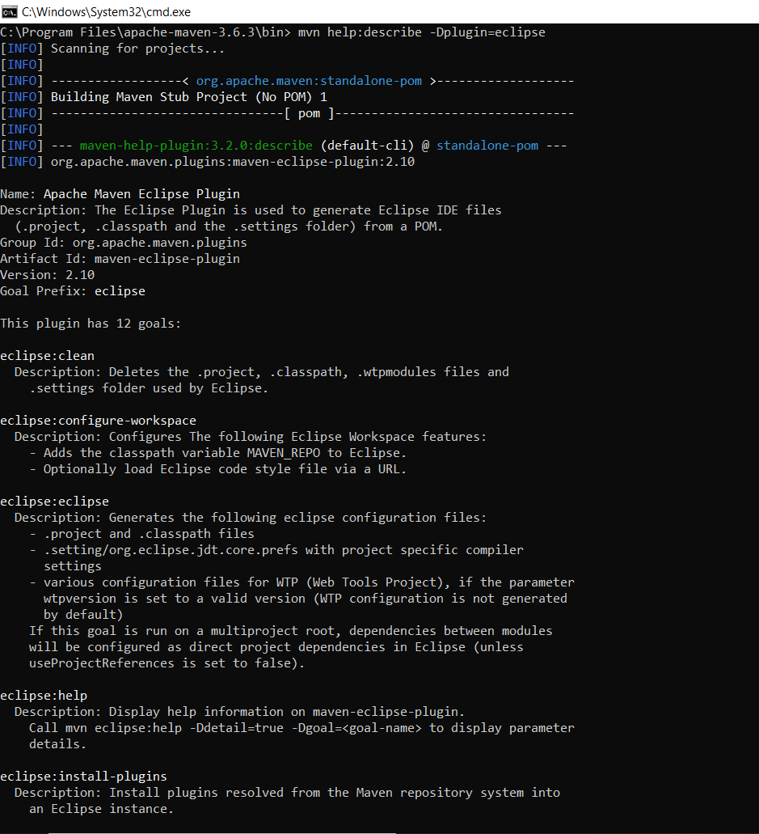

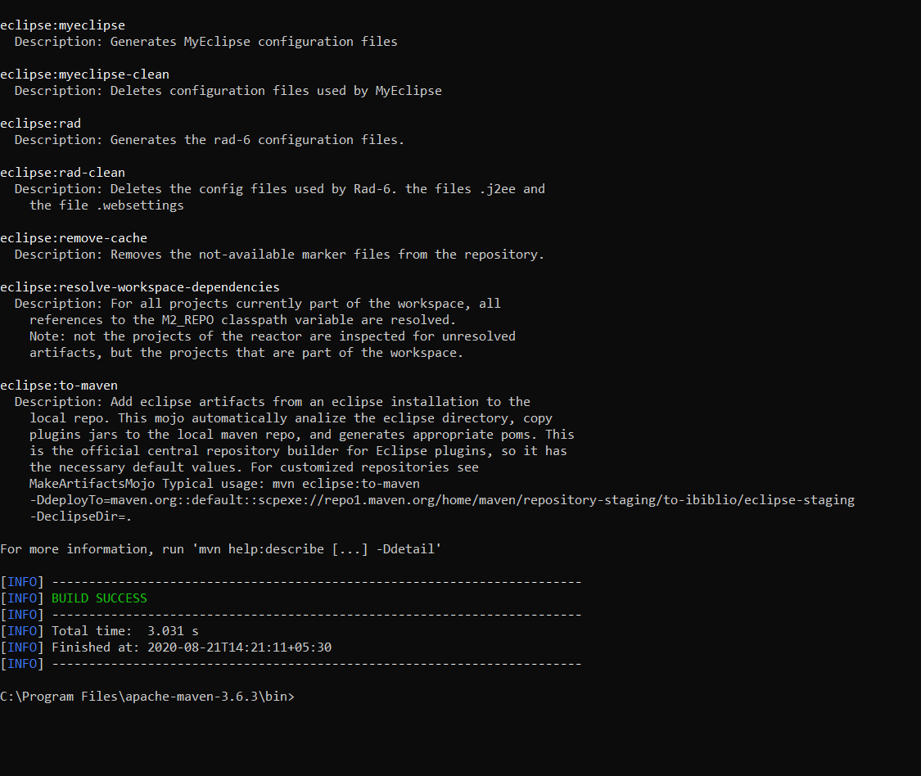

* Write shell scripts / batch files to demonstrate leveraging local copy of maven within the project; and a readme.md on how this is beneficial?

**mvn -Dmaven.repo.local=$HOME/.my/other/repository clean install**

Maven local repository reside in the developer’s machine. Whenever you run maven goals which require these dependencies, maven will download the dependencies from remote servers and store them into developer’s machine.

By default, Maven create the local repository inside user home directory i.e. C:/Users/superdev/.m2 directory. You can change the location of the local repository in setting.xml file using localRepository tag.

<settings>

<localRepository>

C:\M2

</localRepository>

</settings>

Having stored the dependencies into local machine has two main benefits. First, multiple projects can access same artifact so it reduces the storage need. Second, as dependency is downloaded only once, it reduces the network usage as well.

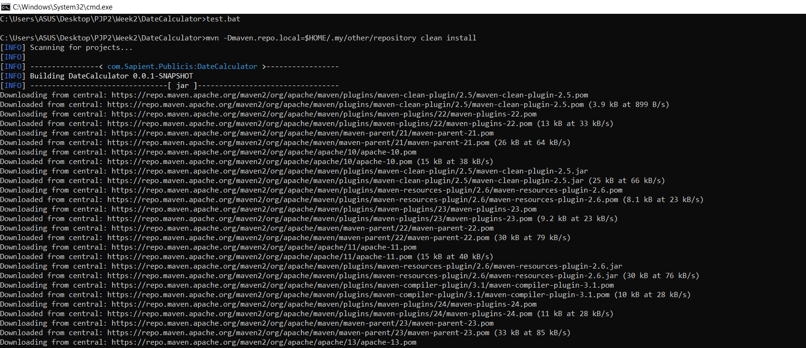

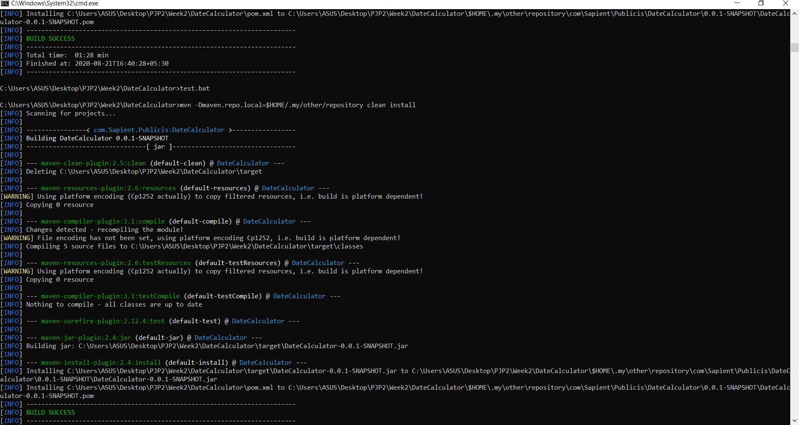

• Write shell scripts / batch files to extract & save the build logs to a file instead of console output

**call mvn install > logfile.txt**

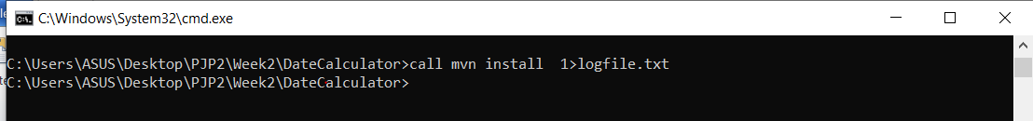

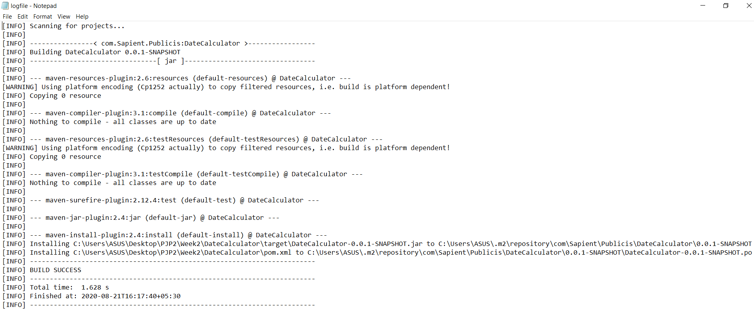

• Write shell scripts / batch files to prevent maven from downloading dependencies every time / Make maven work without internet

**mvn dependency:go-offline**

**call mvn –o clean package**

